18.1 Basics of Brazing and Soldering
Brazing and soldering both are solid liquid processes primarily involve three steps a) heating of plates to be joined using suitable heat source, b) placing and melting of solder or brazing materials followed by heating to the molten state and c) filling of molten filler metal between the faying surfaces of the components to be joined by capillary action and then solidification results in a joint. These three steps are schematically shown in Fig. 18.1 (a-c). An attractive feature of these processes is that a permanent joint produced without melting of parent work pieces. Owing to this typical feature of developing a joint, brazing and soldering are preferred under following situations.
1. Metallurgical incompatibility: Joining of metals having entirely different physical, chemical and mechanical characteristics
2. Poor Weldability: Joining of metals of poor weldability in fusion welding due to cracking tendency, chemical reactivity to ambient gases etc.
3. Unfavorable HAZ: Heat affected zone formed in metal being welded by fusion welding process due to weld thermal cycle causes excessive hardening or softening thus making it not acceptable
4. Odd position welding: Locations of joint which do not allow application of conventional fusion welding technique due to working difficulties like melting of faying surfaces, placing molten metal in places where it is required.
5. Light service conditions: Joint is not expected to take high load & temperature, other adverse atmospheric conditions

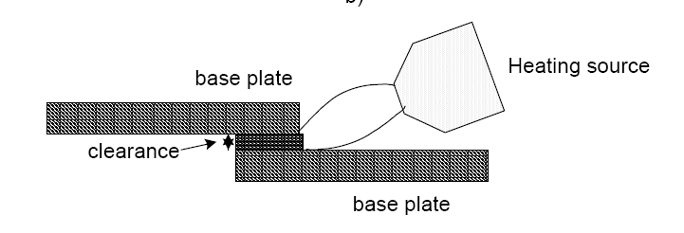
Comparison of brazing and soldering
Both these solid/liquid joining processes can be compared in respect of various factors such as melting point of filler and strength of joint, ability to withstand at high temperature, heating source for developing joint and their applications.
18.3.1 Melting point of filler
Soldering uses the filler metal system having low melting point (183-2750 C generally than 4500C) called solder (alloy of lead and tin) while brazing uses comparatively higher melting point (450-12000C) filler metals (alloys of Al, Cu and Ni).
18.3.2 Strength of Joint
Strength of solder joint is limited by the strength of filler metal. In general, brazed joints offer greater strength than solder joints. Accordingly, brazed joints are used for somewhat higher loading conditions than solder joint.

18.3.3 Ability to withstand under high temperature conditions
In general, braze joints offer higher resistance to thermal load than soldered joint primarily due to difference in melting temperature of solder and braze metal. Therefore, solder joints are preferred mainly for low temperature applications.
18.4 Application
Soldering is mostly used for joining electronic components where they are normally not exposed to severe temperature and loading conditions during service. Brazing is commonly used for joining of tubes, pipes, wires cable, and tipped tool.
18.5. Source of Heat for Joining
Soldering can be carried out using heat from soldering iron (20-150W), dip soldering and wave soldering. Brazing can performed using gas flame torch, furnace heating, induction heating, and infrared heating methods.
18.6 Limitation of Brazing and Soldering
These processes have major limitation of poor strength and inability to withstand at higher temperature with some possibility of colour mismatch with parent metals.
18.7 Role of flux in brazing
Fluxes react with impurities present on the surface of base metal or those formed during joining to form slag apart from reducing contamination of the joints from atmospheric gases (formation of oxides and nitrides due to atmospheric gases). For performing above role effectively fluxes should have low melting point and molten filler should have low viscosity. Fluxes applied over the surface of work piece for developing joint must be cleaned from the work surface after brazing/soldering as these are corrosive in nature.

